Initial Energy Stock
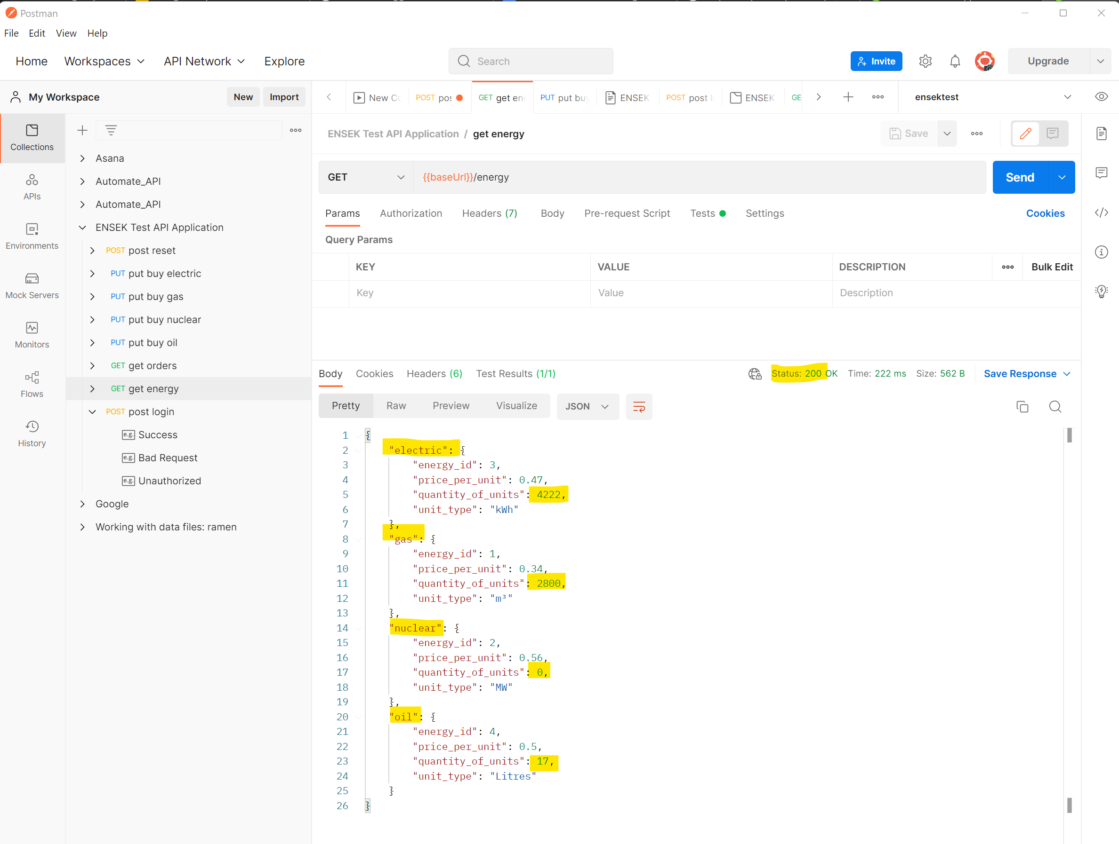

Electric quantity in stock = 4222
Gas quantity in stock = 2800
Nuclear quantity in stock = 0
Oil quantity in stock = 17

Test case 2.2 Buy a quantity of Electric above stock limit
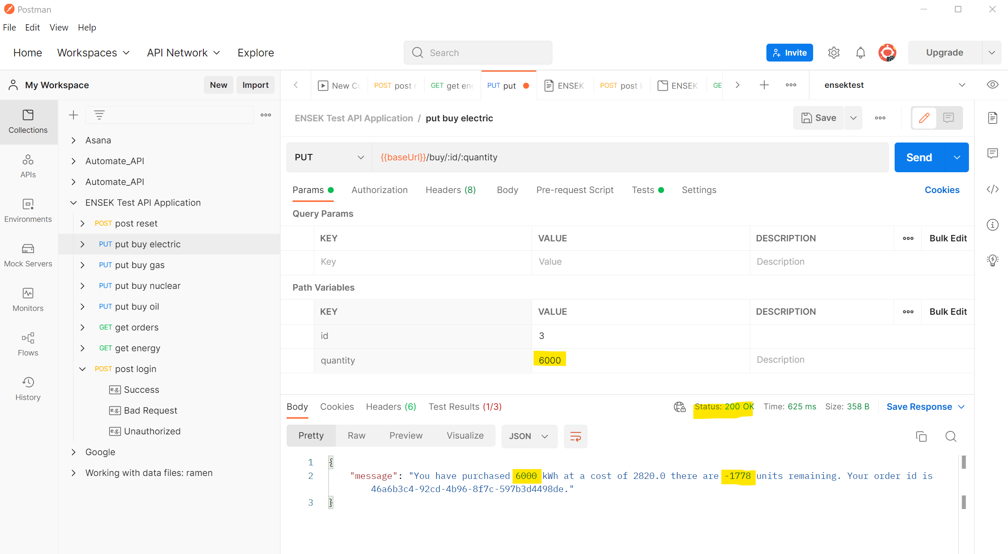
FAIL

Test case 3.2 Buy a quantity of Gas above stock limit
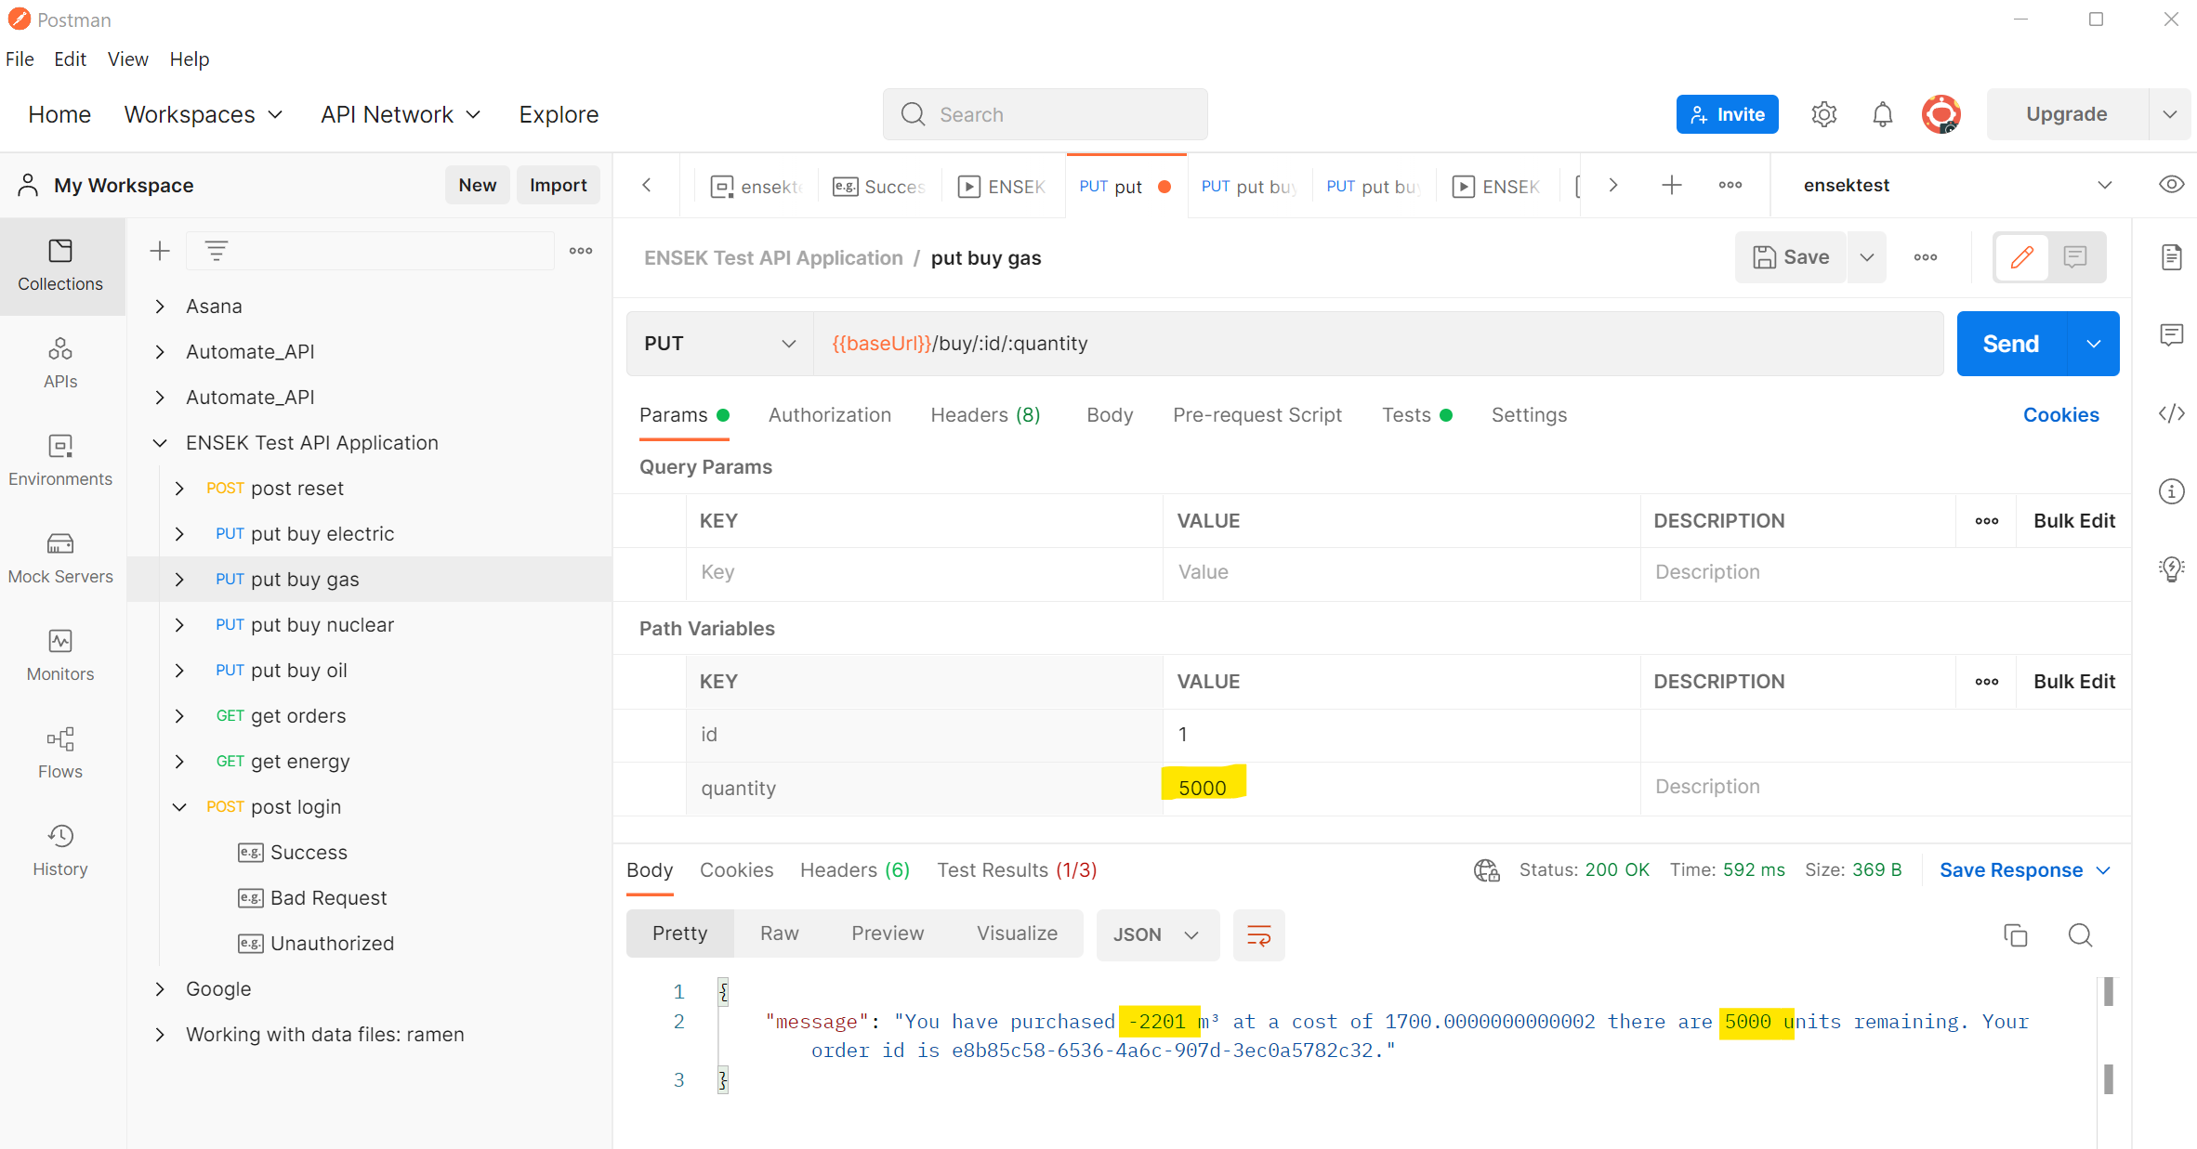
FAIL

Test case 4.2 Buy a quantity of Nuclear above stock limit
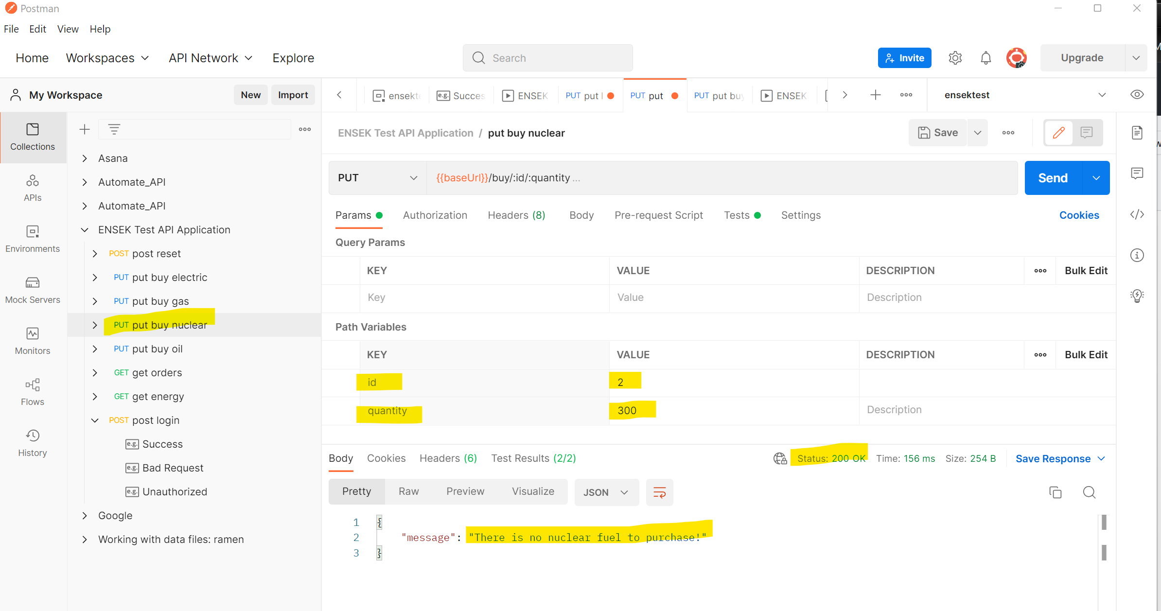
PASS

Test case 5.2 Buy a quantity of Oil above stock limit
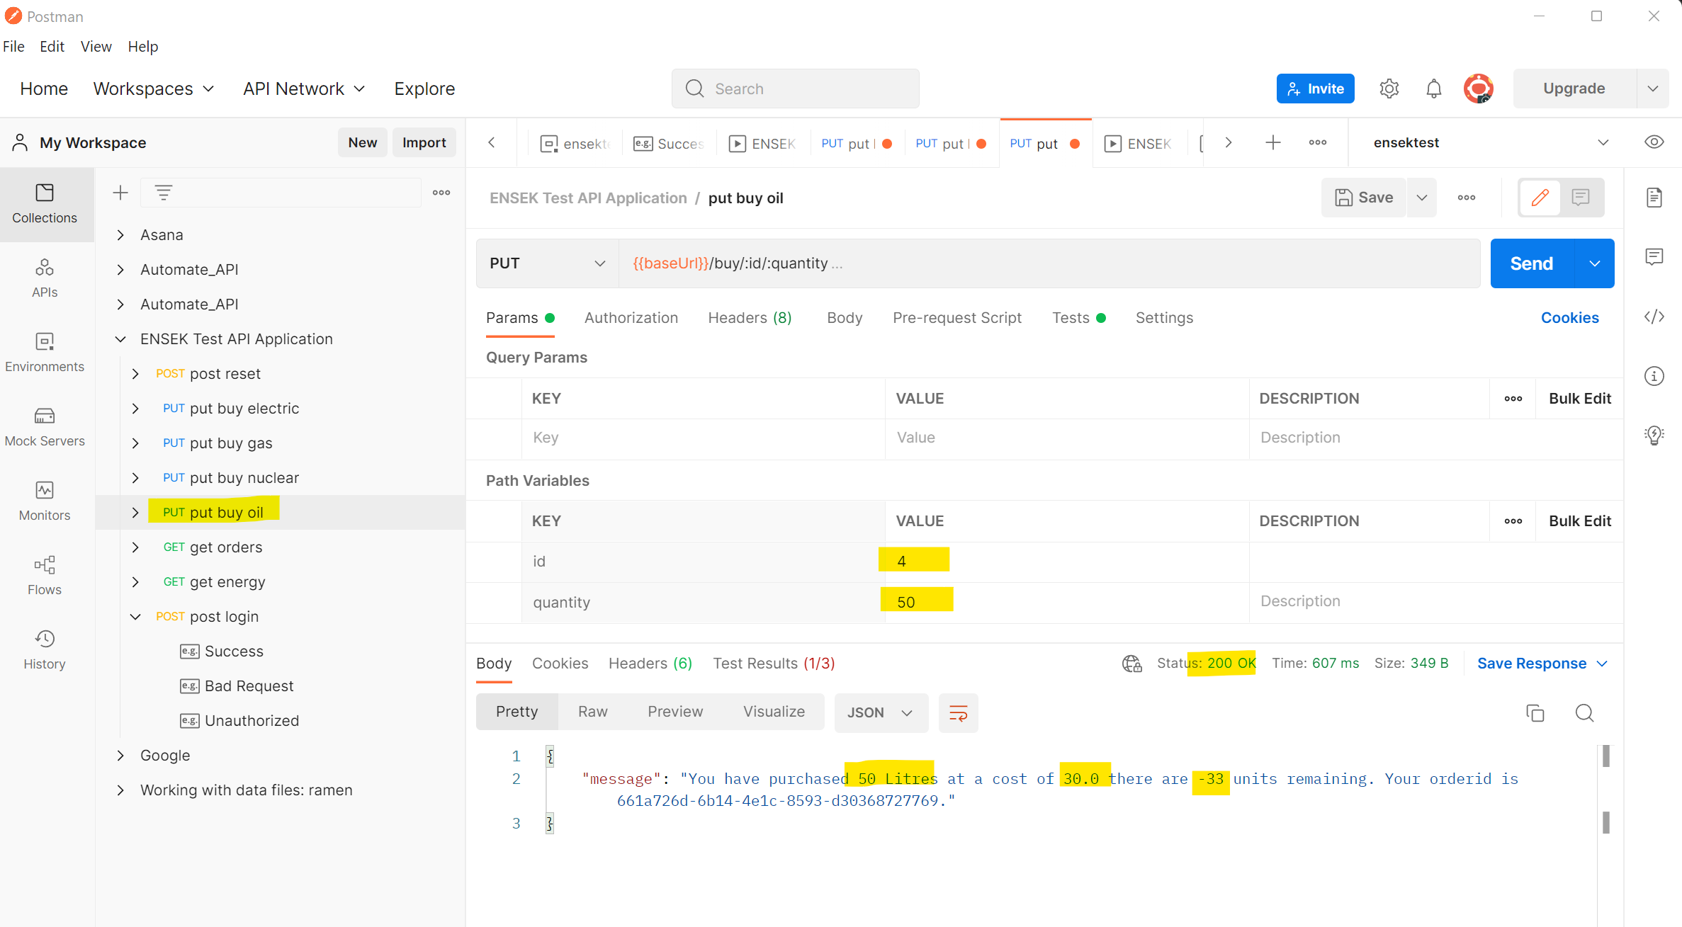
FAIL

Final GET Energy
